ASSIGNMENT 2

PHARMA SALES DASHBOARD

|  |  |
| --- | --- |
| Assignment Date | 23 September 2022 |
| Student Name | SANDHIYA M |
| Student Roll Number | 111519205039 |

QUESTION:

Upload the dataset to Cognos Analytics, prepare the data, explore and Create Interactive Dashboard.

Exploration: Actual Inventory by Month

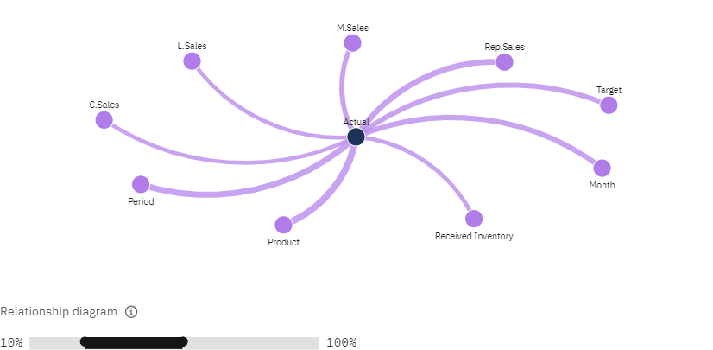

Exploration: Sales By Location.

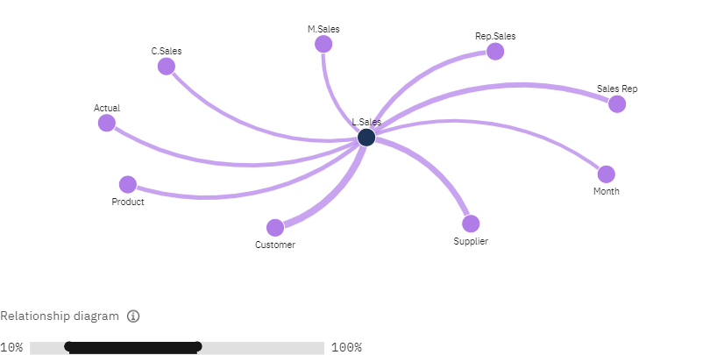

Exploration: Sales by Customer.

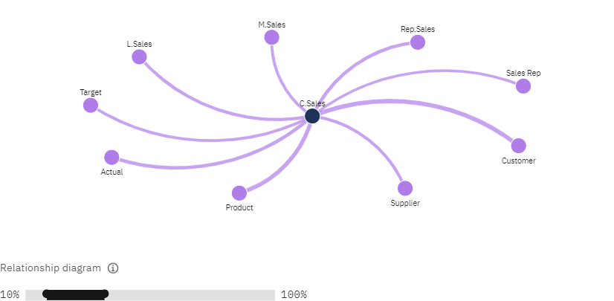

Exploration: Monthly Sales

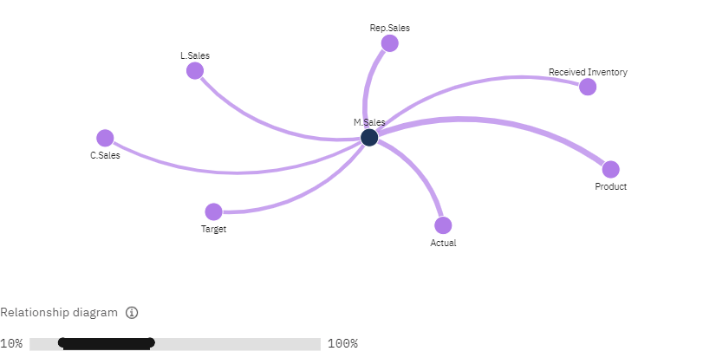

Exploration: Inventory Stock for Warehouse Locations

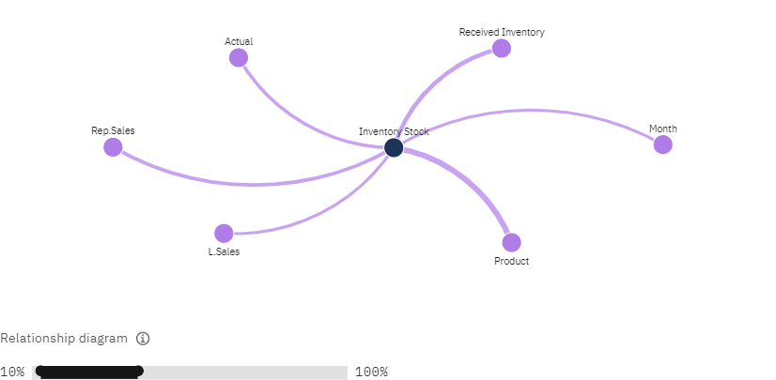

Exploration: Received Inventory from Supplier

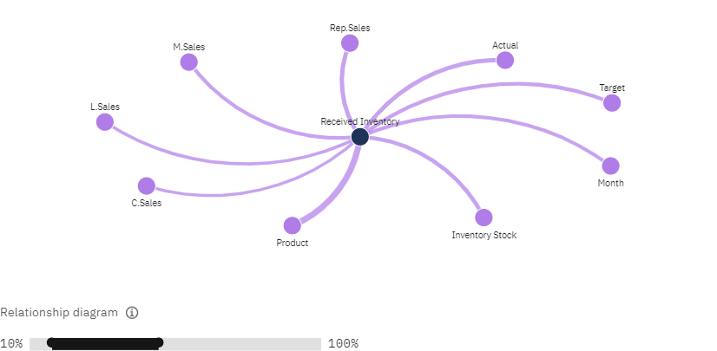

|  |
| --- |
| DASHBOARD  **Tab:**Overview of sales |

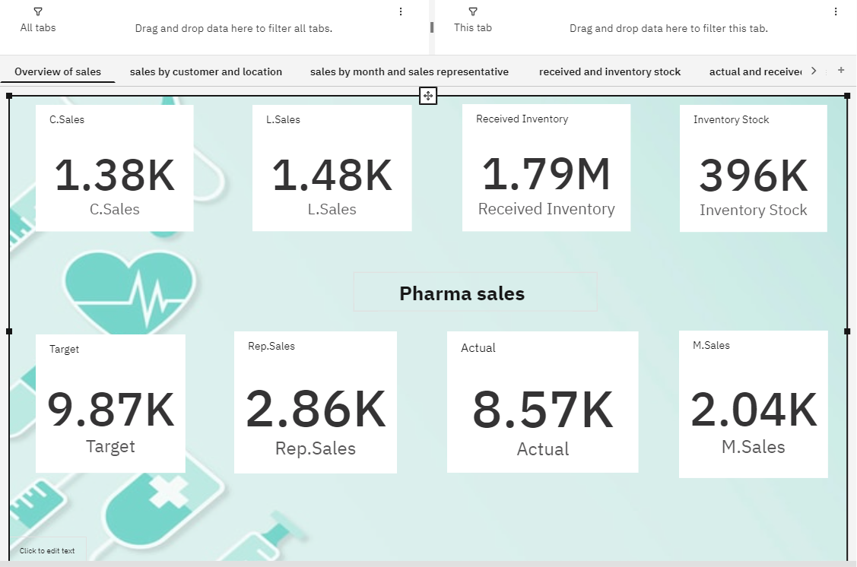

**Tab:**Sales by Customer And Location

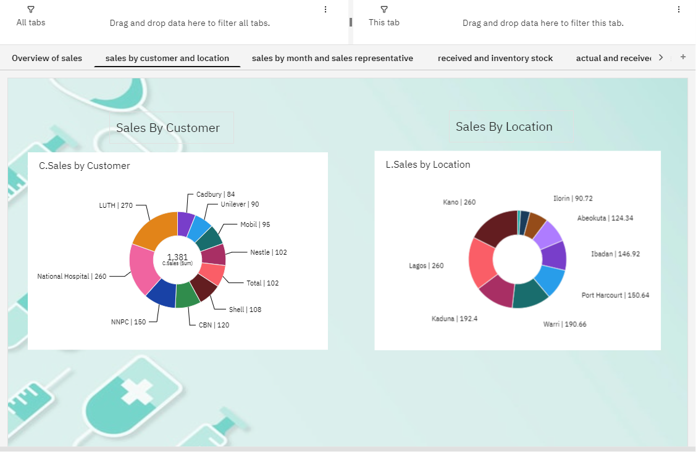

**

**Tab:**Received and Inventory Stock

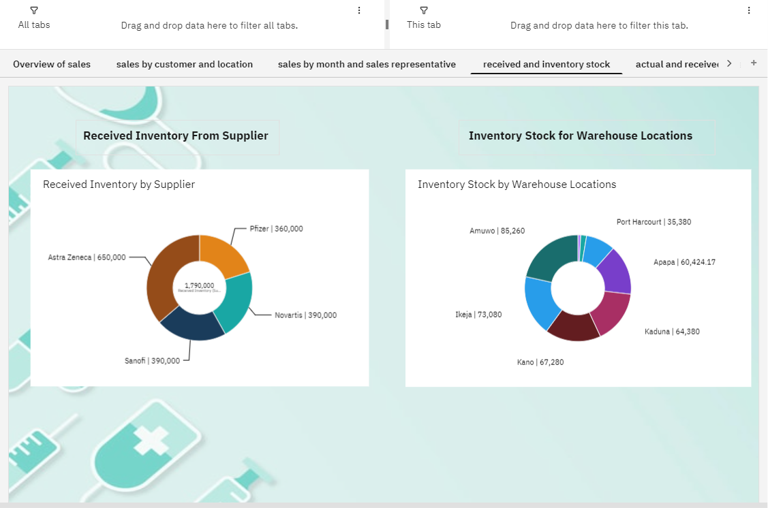

**Tab:**Sales Trend

